Project Design Phase-II
Data Flow Diagram & User Stories

Date | 18 June 2026
Team ID
Project Name | Book A Doctor
Maximum Marks | 4 Marks

Data Flow Diagrams:
A Data Flow Diagram (DFD) is a traditional visual representation of the information flows within a system. A neat and clear DFD can depict the right amount of the system requirement graphically. It shows how data enters and leaves the system, what changes the information, and where data is stored.
Example: DFD Level 0 (Industry Standard)
Example: (Simplified)
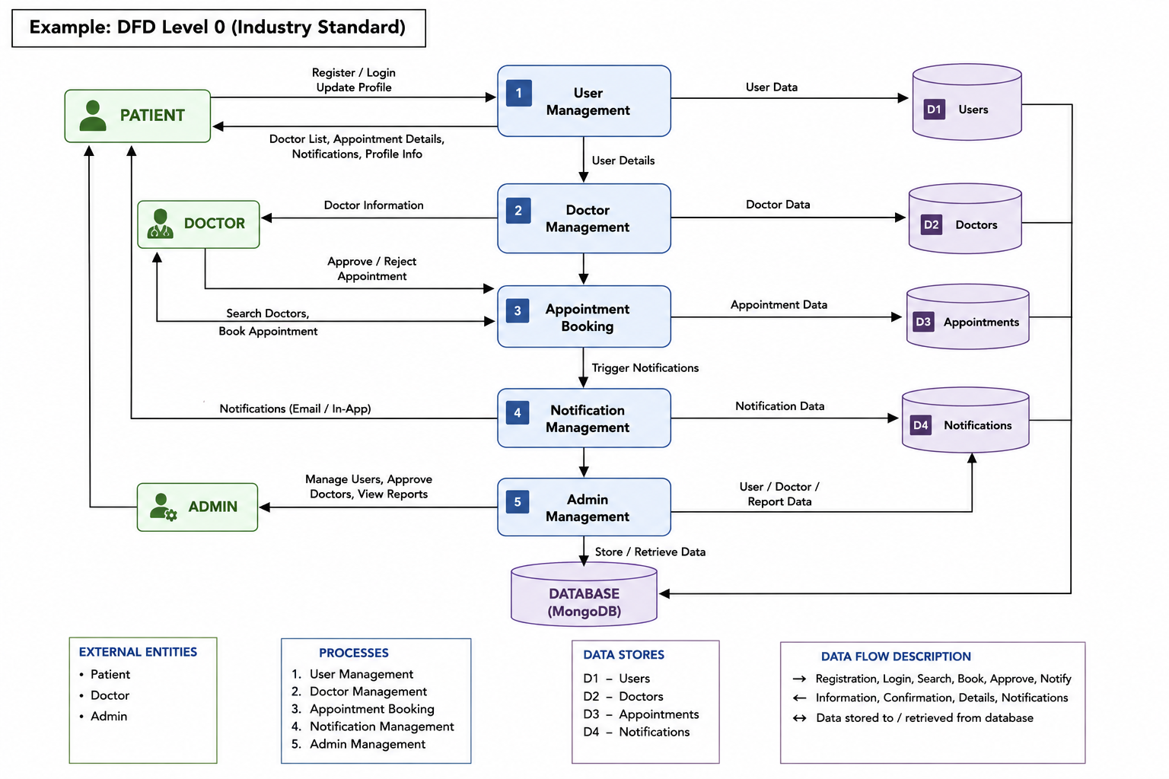
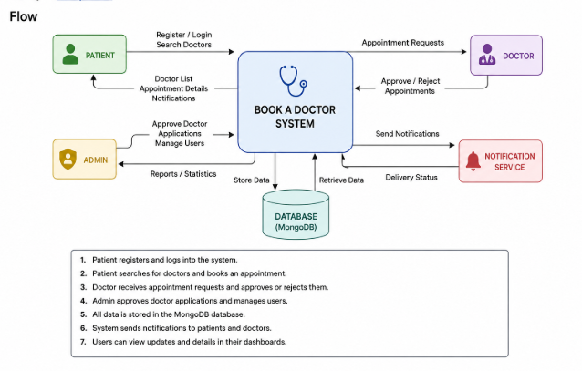

User Stories:
Use the below template to list all the user stories for the product.
User Type | Functional Requirement (Epic) | User Story Number | User Story / Task | Acceptance criteria | Priority | Release
Patient | Registration | USN-1 | As a user, I can register for the application by entering my email, password, and confirming my password. | Patient account is created successfully | High | Sprint-1
Patient | Login | USN-2 | As a patient, I can log in using my email and password | Patient dashboard is accessible after login. | High | Sprint-1
Patient | Doctor Listing | USN-3 | As a patient, I can view the list of approved doctors. | Approved doctors are displayed successfully. | High | Sprint-2
Patient | Appointment Booking | USN-4 | As a patient, I can book an appointment with a doctor. | Appointment request is submitted successfully. | Medium | Sprint-2
Patient | Appointment Management | USN-5 | As a patient, I can view, cancel or reschedule my appointments. | Appointment updates are reflected correctly. | High | Sprint-2
Patient | Notifications | USN-6 | As a patient, I can receive appointment-related notifications. | Notifications are displayed in the notification panel. | Medium | Sprint-3
Doctor | Appointment Requests | USN-7 | As a doctor, I can view appointment requests from patients. | Appointment requests are displayed successfully | High | Sprint-3
Doctor | Appointment Approval | USN-8 | As a doctor, I can approve or reject appointment requests. | Appointment status changes successfully | High | Sprint-3
Doctor | Doctor Dashboard | USN-9 | As a doctor, I can view appointment statistics and upcoming appointments. | Dashboard displays appointment information correctly. | Medium | Sprint-3
Admin | Doctor Management | USN-10 | As an admin, I can approve or reject doctor applications. | Doctor status updates successfully. | High | Sprint-4
Admin | User Management | USN-11 | As an admin, I can manage registered users. | User information is displayed and manageable. | Medium | Sprint-4
Admin | Dashboard Statistics | USN-12 | As an admin, I can view system statistics such as users, doctors and appointments. | Dashboard statistics are displayed correctly. | Medium | Sprint-4

